SE LAB 2

Name: Atharva Mihir Gore

Srn: PES1UG24AM346

Section: AIML F

Epics with user stories
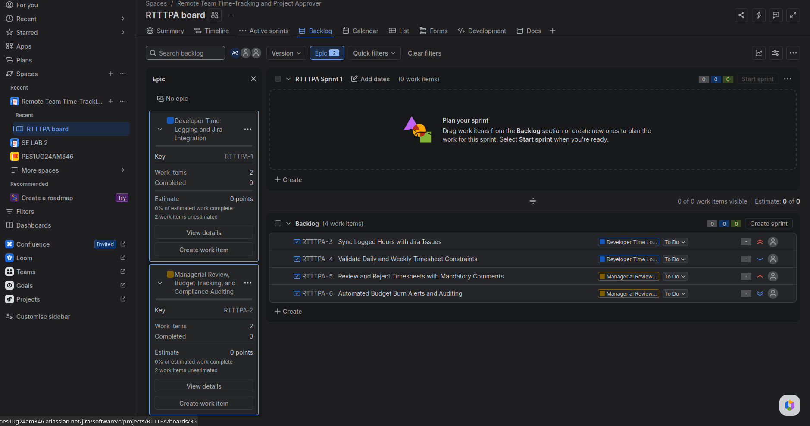

Story point creation
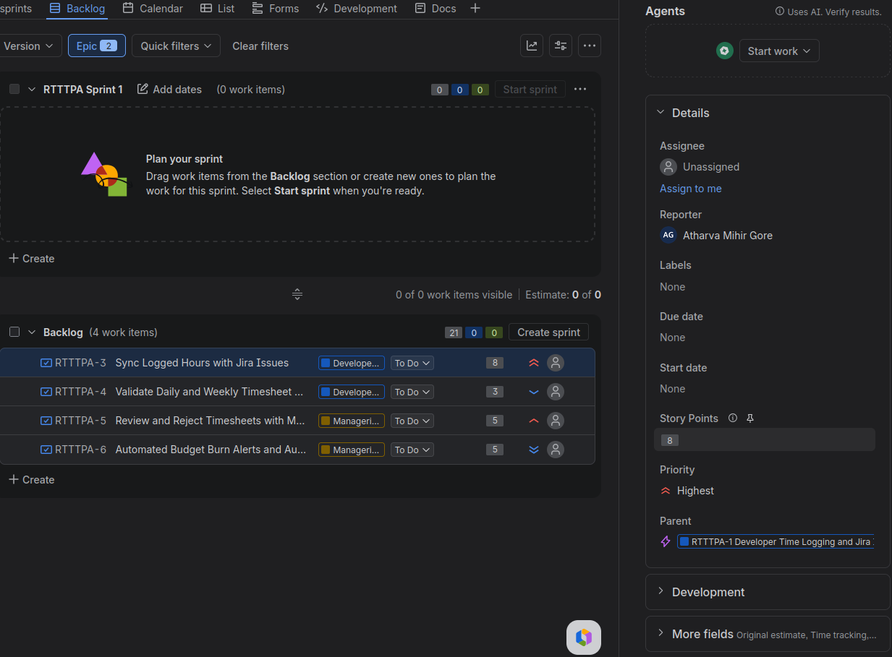

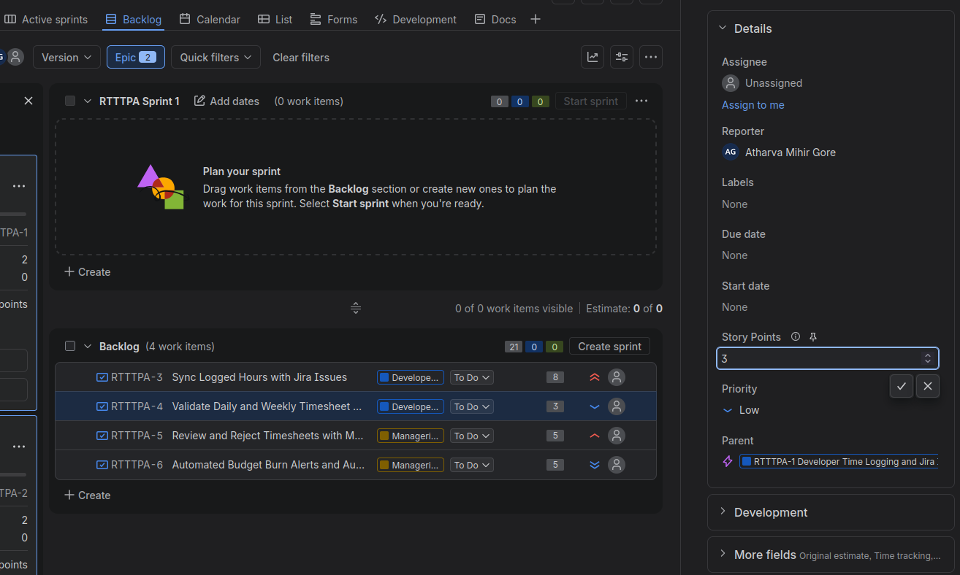
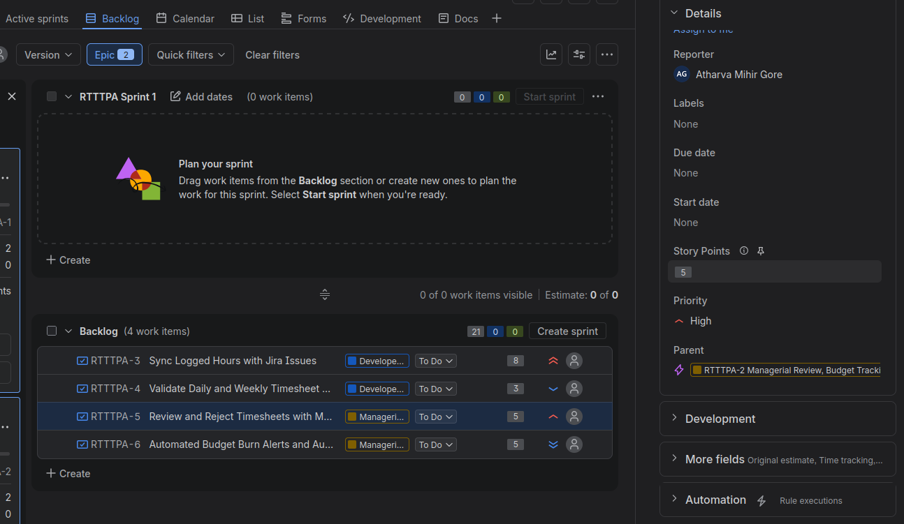
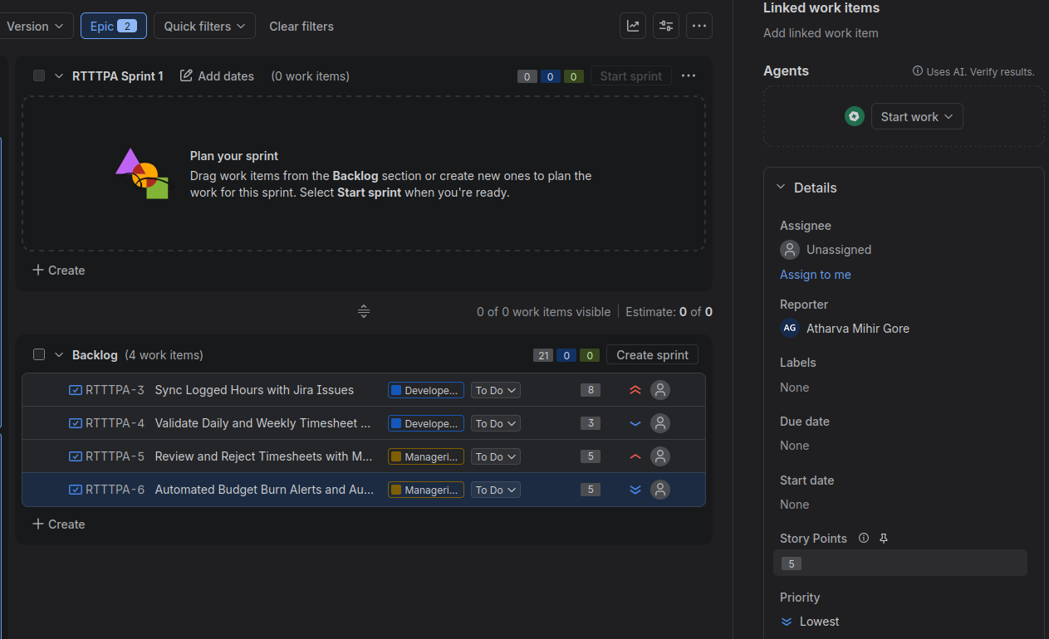

Sprint progress
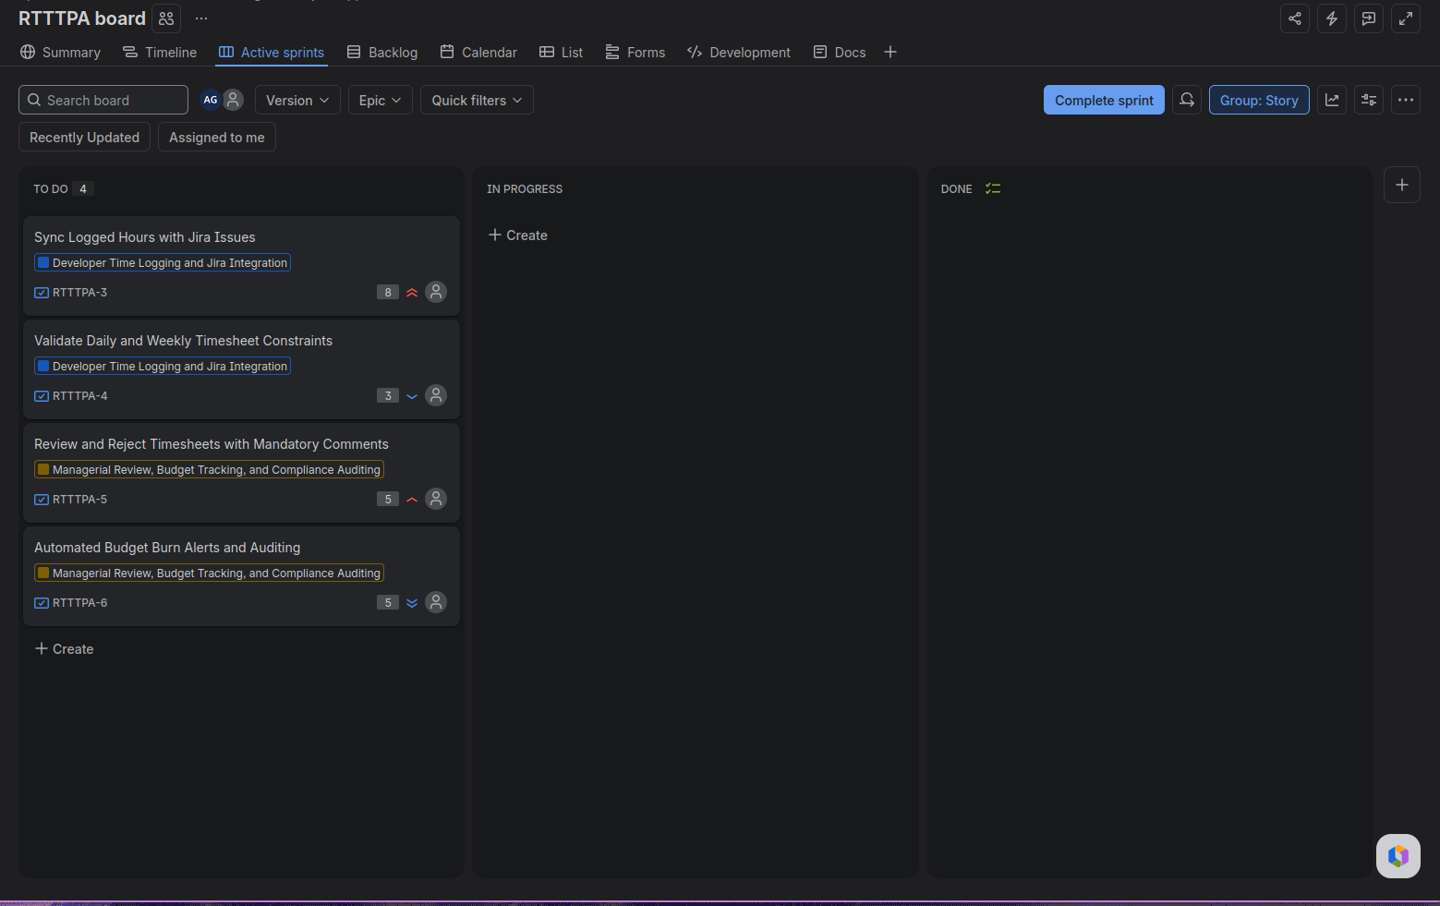
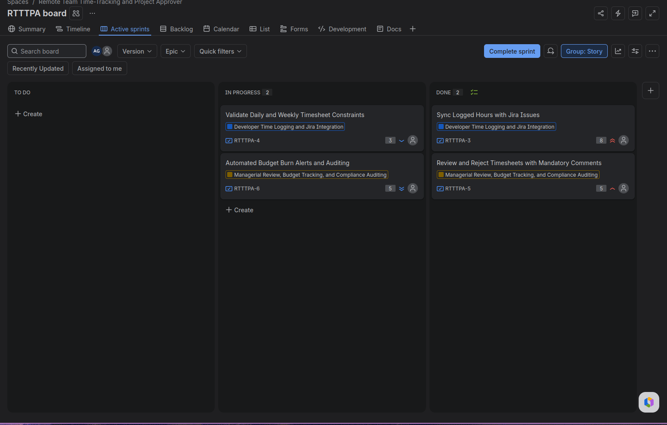
Sprint completion
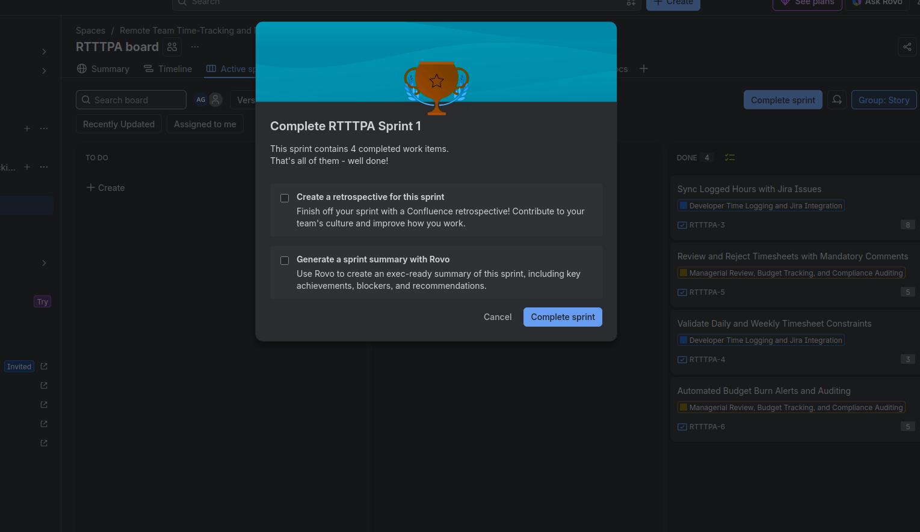
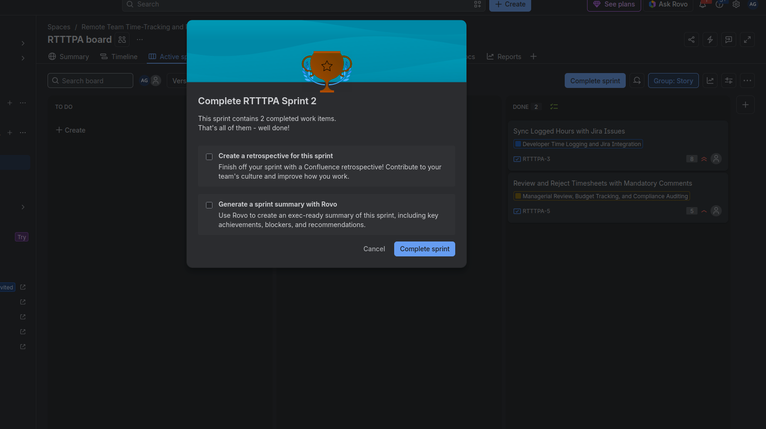
Burn down chart
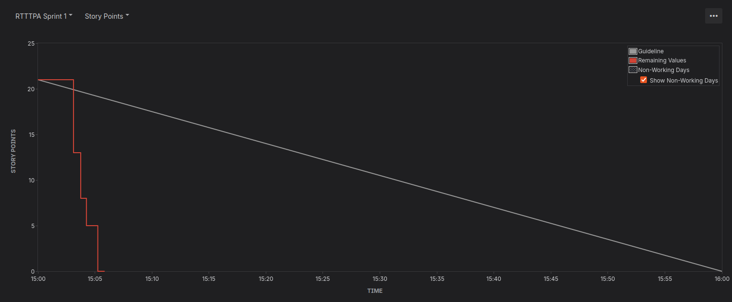

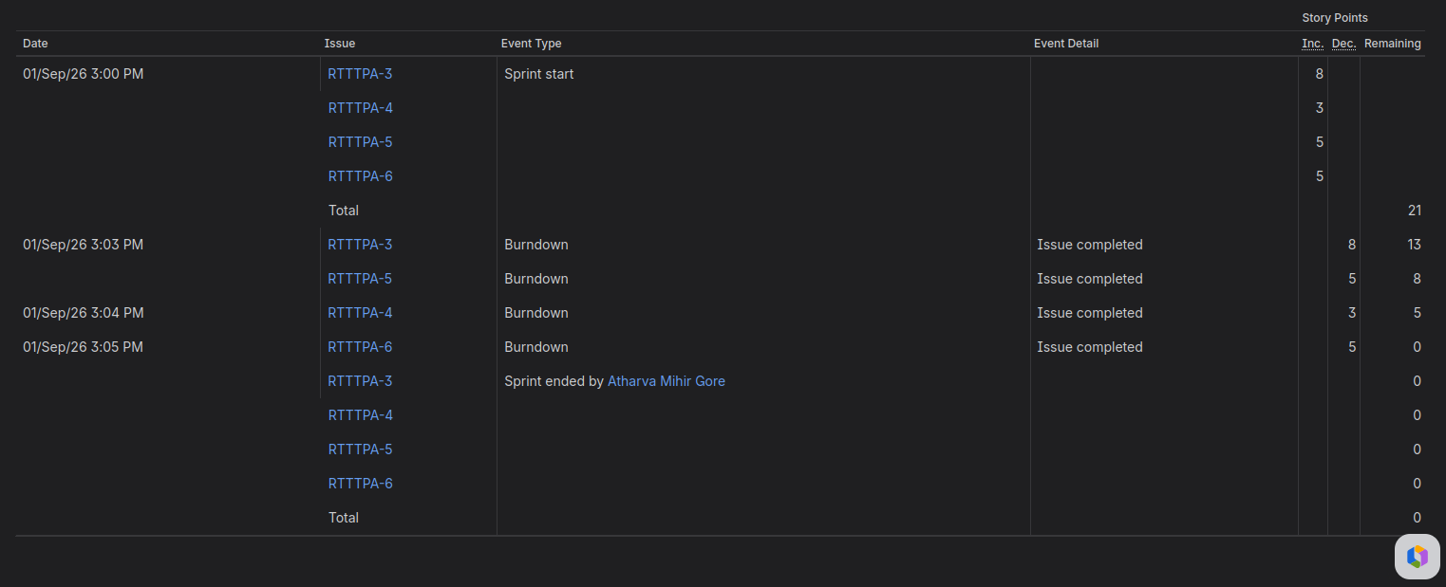

Did your estimations reflect the actual effort? No, the estimations were drastically inflated. If this pattern occurred over a standard two-week sprint, completing a 21-point workload in the first day or two indicates that the tasks were much simpler than their assigned point values suggested, or the team's velocity was heavily underestimated during planning.
Was your backlog well-prioritized? The chart indicates a "batching" anti-pattern rather than smooth prioritization. Instead of a steady, prioritized flow of value delivery where high-priority items finish first, the steep drops show work was either hoarded and transitioned to "Done" all at once, or everything was tackled simultaneously. A well-prioritized workflow typically produces a staggered stair-step pattern.
How did your simulated sprint align with your plan? Execution completely misaligned with the plan. The gray guideline projected a sustainable, even pace of work across the entire sprint container. Instead, the actual burn (red line) fell off a cliff immediately, meaning the sprint goals were met in a fraction of the allotted time, leaving the remainder of the sprint completely empty.
What insights did the burndown chart give about your team’s capacity? The team's true capacity is vastly higher than the 21 points committed. This chart reveals severe under-commitment. To prevent engineers from sitting idle, the team must pull in a much larger volume of work during future sprint planning sessions or completely recalibrate their baseline for what a single story point represents.

